1.3 Discussion: Mobile First

Edward Welborn

The application that was chosen to discuss today is Microsoft OneNote.

This first image is from the website at [www.onenote.com](http://www.onenote.com)

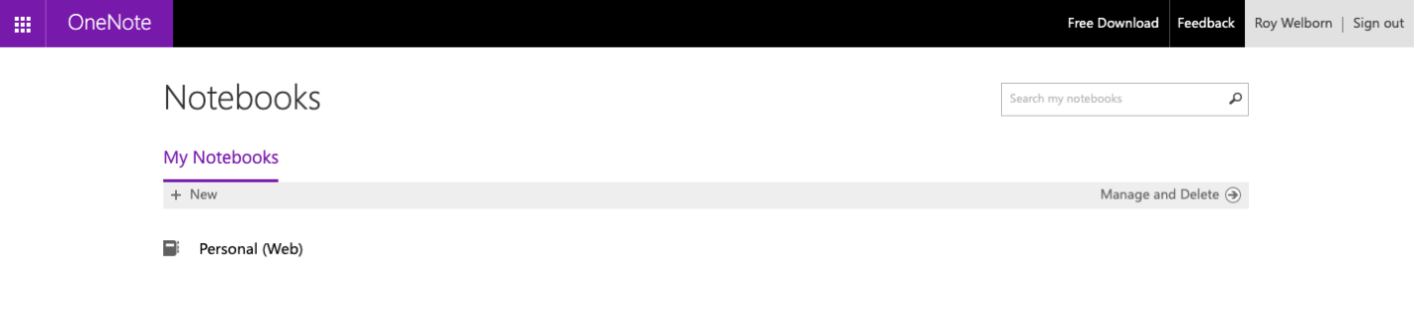

The use of whitespace is prevalent for this website so the user can easily pick out the note that they want to edit or find the button to create a new one.

This second image is from the android application for Microsoft OneNote

This also has quite a bit of whitespace for a clean look that the user can easily find their note to edit or create a new one.

The major difference in the web version and the mobile version is that the editing layout is completely different.

In the web version, it looks like this:

While the mobile version looks a little like this:

The iOS app is different than the android application as well, it has been noticed that a good many product from Microsoft are not consistent across different platforms. Menus are different and not the same across different operating system platforms. Commands and hotkeys, while understandable, are not consistent.

While the look of the product is very minimalistic, the changes in over all look and performance, are a detriment to the usage of this product. Other products of the same genre, such as Evernote have a more consistent overall look, feel, and use.